INDIA’S AGRICULTURAL CROP PRODUCTION ANALYSIS 1997-2021

1 INTRODUCION

1.1 Overview

\*India’s agricultural crop production between 1997 and 2021 exhibited substantial growth,

diversification, and modernization, but challenges of sustainability and climate resilience persists.

* 1. Purpose

\*The purpose of analysing India’s agricultural crop production from 1997 to 2021 is to understand the key trends, challenges, and growth factors that that have shaped the country’s agricultural sector during this period.

2 PROBLEM DEFINING & DESIGN THINKING

2.1 Empathy map

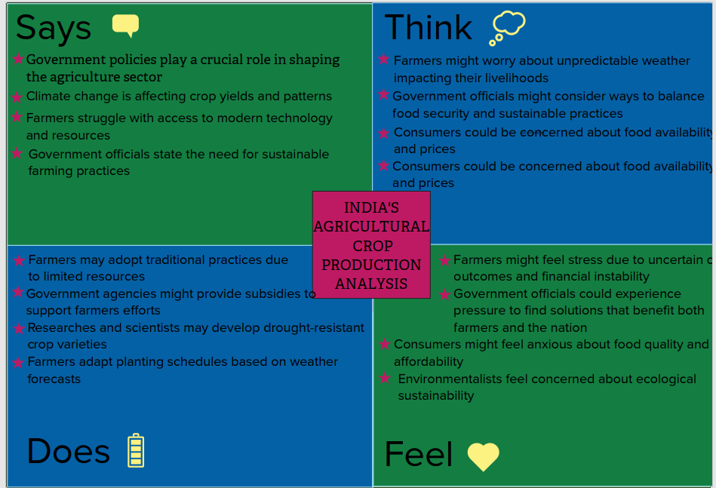

* 1. Ideation & Brainstorming

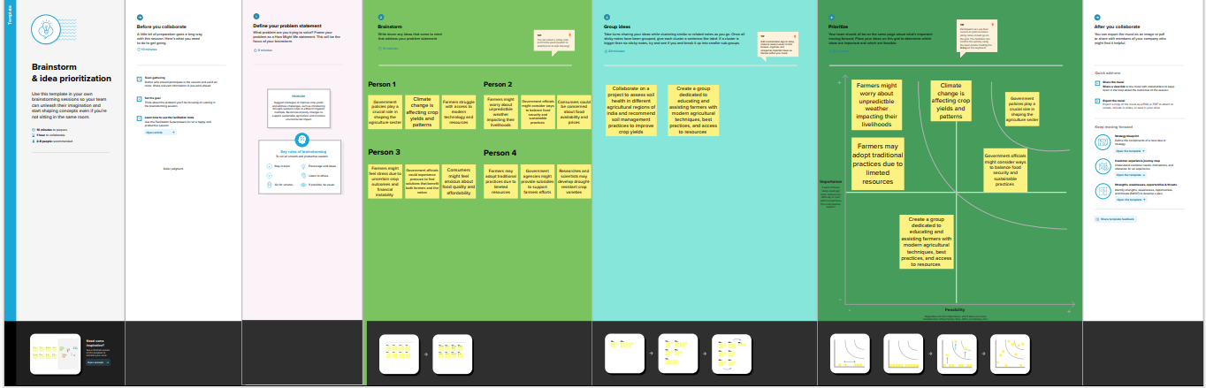

3RESULT

\*India’s Agricultural Crop Production steadily increased from 1997 to 2021

4 ADVANTAGES & DISADVANTAGES

4.1 Advantages of India’s Agricultural Crop Production 1997-2021:

\*Improved food security

\*Diversified crop portfolio

\*Economic contribution to GDP

4.2 Disadvantages of India’s Agricultural Crop Production 1997-2021:

\*Vulnerability to climate change

\*Uneven distribution of benefits

\*Environmental concerns

5 APPLICATION

\*This analysis can support precision farming initiatives to optimize crop yields and resource use

6 CONCLUSION

\*India’s agricultural crop production from 1997-2021 has shown growth, but challenges remain in ensuring sustainability and equitable distribution

7 FUTURE SCOPE

\*Leveraging advanced technology for precision agriculture to enhance crop yields and sustainability in India